APPLICATION FORM - CATEGORY 1 FUNDING
Name of Organisation Applying for Funding: Autism Community Network

ABN 64 103 662 535

Council Area: Hurstville

Is your organisation a non-profit organisation? X Yes
Is your organisation incorporated? X Yes

If yes, please indicate which form of incorporation below:

- A company limited by guarantee
- A co-operative
- An incorporated association X
- An unincorporated association
- Other – please detail below:

Primary Contact Details:

Title: Mr Name: Steve Drakoulis
e.g. Mr/Mrs/Ms

Postal Address: P.O. Box 188

Suburb: Riverwood State: NSW Post code: 2210

Phone: 9543 9036 / 0431724229 FAX: N/A

Email: steve@autismcommunity.org.au

Secondary Contact Person Details:
Title: Mr Name: Warren Thompson
e.g. Mr/Mrs/Ms

Phone: 9543 9036 / 0410 850 508 FAX: N/A

Email: warren@autismcommunity.org.au

IMPORTANT INFORMATION
LOCAL COMMITTEE INDEX: Information on where and how to apply to each Local Committee (based on local government area) is also available on the ClubsNSW website (www.clubsnsw.com.au) by following the ‘Local Committee Index’ Link. If your area has a local committee, please contact the local committee convenor or council before applying. Also read the latest ClubGRANTS guidelines, available from www.clubsnsw.com.au

REMINDERS:

- Applications should be sent to local committees or individual clubs, where appropriate. Applications sent to ClubsNSW will be returned.

- There is no application form for Category 2 funding. In relation to Category 2 grants, applicants should liaise directly with individual ClubGRANTS clubs in their local area – a listing is provided on the ClubsNSW website.

- Please do not attach lengthy covering letters or appendices to your application.

FURTHER INFORMATION: Please call ClubsNSW on 02 9268 3000 or email enquiries@clubsnsw.com.au for further information.

If your application for funding is successful you will be required to:
- make an appropriate level of acknowledgement of the funding source for the project;
- complete an evaluation form at the end of the project.

Q1. Project Name: AUBURN AUTISM SUPPORT AND SOCIAL GROUP

Q2. Project Sponsors (if applicable): ______________________________________________________________________________
Cumberland Council (Formerly Auburn Council)

Q3. Please provide an outline of your project (what you are going to do or provide, e.g. details of your event, service, product etc).

The group will run once a month, allowing parents and carers of children on the autism spectrum to come together for mutual support. The facilitator will bring new information to help them connect with local services, funding support, news and tips. The parents will have someone they can talk to who understand them, and learn from each other’s experiences. Social isolation is a debilitating experience and one that families of children with challenging issues regularly encounter. We know from running groups all over Sydney that for many, this type of support group is a great outlet for them where they feel that they are not alone.
While the parents are talking, the children will have a variety of social opportunities within a safe, supported environment. A place where they can build on their social skills without being judged, and develop confidence and friendships

Q4. Which of the following community priorities below does your project address? Please tick ONE (1) BOX ONLY.

X A4 - aged, disability or youth services

Q5. Who will your program benefit?

X Children (0-14 years)
X Young People (15-24 years)
X Families
X People from non-English speaking backgrounds
X People with disabilities

Q6. How many local residents will your project benefit?
Recipients: White the Autism Community Network currently has only 8 families registered residing within the LGA, there is little autism support services in the west or inner west so we expect to grow this group from within the area and the wider area as well.

Volunteers: 1

Q7. If you expect indirect beneficiaries, who might they be?

Residents, businesses and venues will benefit with families experiencing autism able to participate more in local activities and be a greater part of their local community.

Q8. What impact do you hope to have on your identified local community priority needs?

Parents’ feelings of isolation lessen as they are supported by those who understand first-hand how difficult their lives sometimes are. They share the positive stories as well as those that have caused them distress. The group is an outlet for their worries, concerns, stresses and joys. It is also a vehicle for sharing information on intervention theories, services available, training available, strategies for school, and what has and has not worked for them and their child. Maintaining and growing these groups will enable us to help meet this vital need.

The result is parents who feel less alone, more positive about the work they are doing to help their child progress, more optimistic about the future and more informed about the choices available to them.

Q9. How will you know that you have made a difference (and measure your outcomes?)
The program will be evaluated through:
Recording attendance figures
Annual Survey

Q10. What is the proposed commencement date and completion date for the project?

1 July 2016 to June 30 2017

Q11. Does the project need to be followed up after completion? If yes, how?

Our goal is to continue the program in some format in the longer term.

Q12. What are your plans to ensure that the benefits of the project will be sustained (that is, continue after the project has finished and/or there is no more funding available?)

We always look for volunteers to help us run projects in the community, if we can continue to build on the popularity of this program we hope to encourage families to continue on with someone putting their hand up to facilitate it as a volunteer.

Q13. Are you working with other partners in this project, or have you asked for support from anyone else?
x Yes

Q13a. If yes, please provide contact details:

Auburn Council provide the venue free of charge and promote the group

Q14. Is anyone else doing a similar project in this LGA with your target group?

Yes x No Not known

Q14a. If yes, who? Have you spoken to them about collaboration/ ensuring non-duplication of services?

Q15. Is this program, project or service already assisted by an existing local, State, or Commonwealth Government funding program? If yes, please give details (how much, which program):

Yes – we have a partnership with (the former) Auburn Council where they provide the venue for a monthly meeting, but to grow this group long term we need funds to cover costs.

Q16. What is the total amount of ClubGRANTS funding you are seeking for this application?
$2470

Q17. Can your project be broken down into smaller sections for part-funding? If so, how?

We could run it with a volunteer facilitator but would be limited in activities and resources for both children and parents.

Q18. Have you applied, or do you intend to apply, to any other registered club or funding body for this project (including applications in other areas)?
x No
If yes, please identify:

Q19. Will ALL the ClubGRANTS funding you have requested be spent within the Local Government Area in which you are applying?

X Yes

Q19a. If no, approximately what percentage will be spent outside the local area?

Q20. Has your organisation received funding from the ClubGRANTS scheme before?
X Yes No
Q20a. If yes, in what year, for what purpose and how much?
Year | Council / Clubs | Program | Grant
2013/14 | Hurstville | Autism Kids Drama | $4808
2013/14 | Kogarah | Autism Kids Drama | $3000
2013/14 | Sydney | Music Club | $2000
2013/14 | Marrickville | Music Club | $4600
2013/14 | Sutherland | support group | $4830
2014/15 | Bankstown | Art Club | $4866
2014/15 | Randwick | support group | $3744
2014/15 | Hurstville | support group | $4900
2015/16 | Sutherland | Fit and Friendly | $5600
2015/16 | Parramatta | support group | $4800
2015/16 | Hurstville | Fit and Friendly | $5300
2015/16 | Canterbury | Drama | $5000

Note: Organisations that have not submitted their report / progress forms will not be considered for further funding.

Q21. Please outline below the project budget for your proposal, including funding from this source (ClubGRANTS) and any other funding sources. E.G. salaries, program costs, capital equipment, rent, etc.

Income |  | Expenditure
Description | $ | Description | $
Cumberland Clubs Grant | $2470 | 11 sessions x 1 facilitator @$30/hr x 3hrs | $990
ACN in kind volunteer | $660 | Travel $10 x 11 sessions | $110
Auburn Council  Multipurpose Room $ 47.20 plus Youth Space $ 13.60 per session | 668.80 | Insurance $10 x 11 | $110
 |  | supervision / administration / promotion 11 sessions x $50 | $550
 |  | 11 sessions x 1 volunteer @$20/hr x 3hrs | $660
 |  | Guest Speakers | $300
 |  | Resources (games, equipment etc) | $300
 |  | Food & Beverage ( $10 x 11) | $110
 |  | Council in-kind donation of meeting space | $668.80
TOTAL INCOME | $3798.80 | TOTAL EXPENDITURE | $3798.80
*If more room is required, please attach extra information on a new page.

Q21a. Please provide your organisation’s banking details

Account Name: Autism Community Network Inc

BSB No: 062234 Account No: 10417253

Q21b. If the club wishes to provide a cheque, please advise as to who the cheque should be made out to for this purpose:

Q21c. Please attach a copy of your last annual report including financial statements, if applicable

Declaration, Authority and Consent

The applicant declares that the application information is true and correct. The Applicant will notify the Local Committee and/or club of any changes to this information and any circumstances that may affect this application.

The applicant authorises and consents to the Local Committee and/or Club:

- Referring this application (as necessary) to external experts for assessment, reporting, advice, comment or for discussions regarding alternative or collaborative funding opportunities.

- Disclosing the Application Information to ClubsNSW and to ClubsNSW collecting, aggregating, having access to, using, disclosing and publishing the Application Information for a ClubsNSW purpose.

“Application Information” means all information and data (including email and personal information) provided within this document.

“ClubsNSW Purpose” means:

- To quantify the social contribution made by registered clubs by the making of grants; and

- To use, disclose and publish the Application Information which it collects and aggregates from Clubs in ClubsNSW’s capacity as an advocate on behalf of the Club industry.

I understand that this is an application only and may not necessarily result in funding approval.

I am authorised to submit this application and agreeing to the Declaration, Authority and Consent.

I have read and agreed to the above.

Authorised Person:

Title: __Mr_____ First Name: Steve Last Name: Drakoulis

Position: Operations Manager

Contact Number: 0431 724 229

Signature: 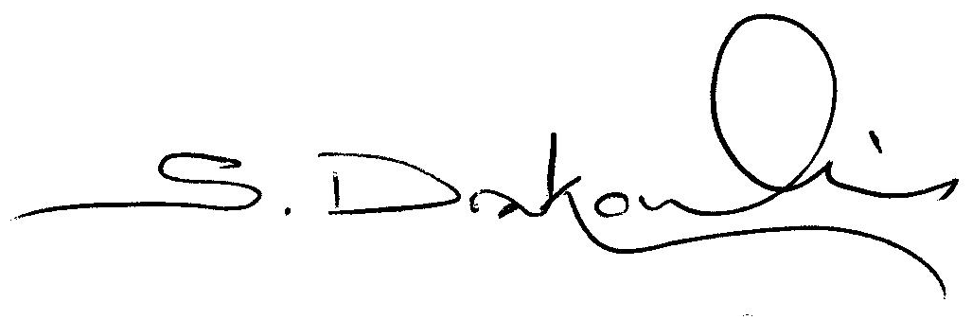 Date: ____3/6/2016_____________

