CSG ID______
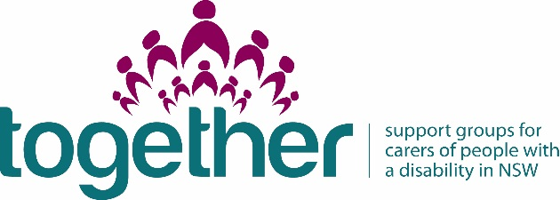
Financial Report & Acquittal 2015-16

Carers NSW requires all organisations that have received support group funding to submit this Financial Report & Acquittal form to report on how funds have been spent.

Name of RAO:_____ Carers NSW_Blacktown _______________________________________

Name of person completing this form: Magdalena Oszywa

Contact phone number:________0422975328___________________________________________________

Contact email:_______treasurer@autismcommunity.org.au___________________________________________________________

Name of Carer Support Group:_____________________________________________________

Please specify how funding was spent

Sustainability grant from Carers NSW for CSG (inc GST) in 2015-16 | $500.00
List line item | Dollar amount spent
Insurance | $100.00
Telefon | $50.00
Beauty Salon visit | $294.00
Travel | $56.00
PROJECT TOTAL VALUE: | $500.00
2015-16 acquittals are due by August 31 2016.

Please email completed acquittal to together@carersnsw.org.au

