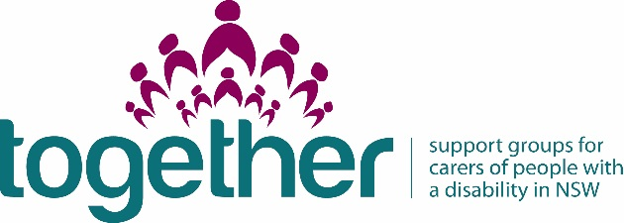
Appendix C
Financial Report & Acquittal
Carers NSW requires all organisations that have received support group funding to submit this Financial Report & Acquittal form to report on how funds have been spent.

Name of RAO: AUTISM COMMUNITY NETWORK (ACN)

Name of person completing this form: STEVE DRAKOULIS

Contact phone number 0431 724 229

Contact email: steve@autismcommunity.org.au

Name of Carer Support Group:

Please specify how funding was spent

Funds provided by Carers NSW for CSG (inc GST) in 2015-16 | $1000.00
List line item | Dollar amount spent
TOTAL spend
$1000
PROJECT TOTAL VALUE: | $1000
2015-16 acquittals are due by August 31 2016. | $1000

Please email completed acquittal to together@carersnsw.org.au
Group Therapy Sessions
• Paid professional to attend

Group meeting costs Do you need supplies for your group?
• Venue hire costs, fees for meetings, including setup/pack up time.
• Tea/coffee, cups, spoons, urn hire, kettle purchase.
• Biscuits, cakes
• Cleaning equipment cloths, washing up detergent
• First aid kit
• Insurance costs for group

Education, training & group knowledge
• Stocking a support group library; purchasing relevant books, DVDs and other resources
• Postage,-envelopes paper stamps newsletters flyer and special events
• Printing colour flyers, brochures copying
• stationary costs pens paper
• reflective dairy/journals
• name tags
• black board, white board,
• Guest speaker/educator travel costs, including any translating and interpreting fees.

Professional development for volunteer facilitators
• Attend Carers NSW biennial conference
• Computer course to assist whoever manages group finances
• First aid course
• CPR course

